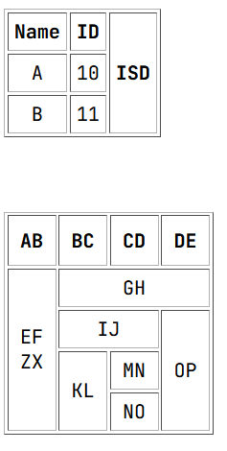
Lab Task 01- WEB TECHNOLOGIES

